\*\*Local variables take precedence to instance variables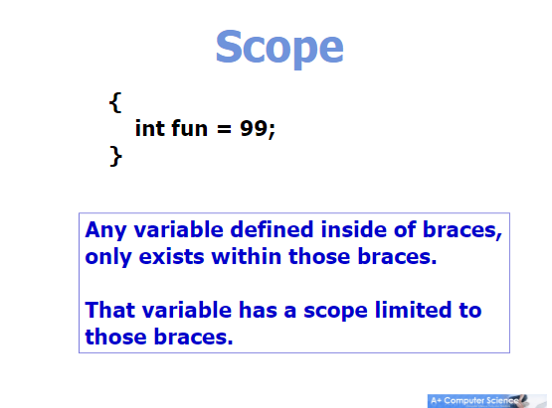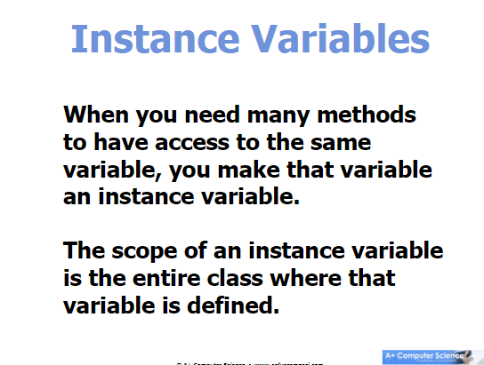

\*\*Make sure not to make a NEW variable inside some code thinking you’re actually using the INSTANCE variable itself